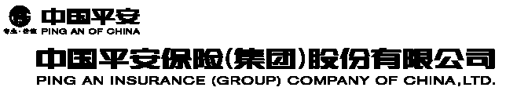
(A joint stock limited company incorporated in the People’s Republic of China with limited liability)

(Stock Code: 2318)

ANNOUNCEMENT

This announcement is made regarding the information concerning premium incomes of the subsidiaries of the Company to be released on CIRC's website.

Reference is made to the announcement of Ping An Insurance (Group) Company of China, Ltd. (the "Company") dated August 27, 2004. The premium incomes of Ping An Life Insurance Company of China, Ltd., Ping An Property & Casualty Insurance Company of China, Ltd., Ping An Health Insurance Company of China, Ltd. and Ping An Annuity Insurance Company of China, Ltd. for the period from January 1, 2007 to June 30, 2007 were RMB 42,218.37 million, RMB 11,515.82 million, RMB 0.34 million and RMB 30.00 million respectively. Such information will be released on the website of China Insurance Regulatory Commission ("CIRC") (http://www.circ.gov.cn). The figures are based on unaudited management accounts which have not been reviewed by the Company's audit committee and are prepared in accordance with accounting rules and regulations in the PRC, i.e. PRC GAAP which are different from the international accounting standards adopted by the Company in preparing its financial statement published and to be published in accordance with the Listing Rules.

As the information to be disclosed by CIRC is based on unaudited financial information, investors are advised to exercise utmost caution when dealing with the shares of the Company.

By order of the Board
Yao Jun
Joint Company Secretary

Shenzhen, PRC, July 20, 2007

As at the date of this announcement, the Executive Directors of the Company are Ma Mingzhe,
Sun Jianyi and Cheung Chi Yan Louis, the Non-executive Directors are Lin Yu Fen,
Cheung Lee Wah, Anthony Philip HOPE, Fan Gang, Lin Lijun, Hu Aimin, Chen Hongbo,
Wong Tung Shun Peter and Ng Sing Yip, the Independent Non-executive Directors are Bao Youde, Kwong Che Keung Gordon, Cheung Wing Yui, Chow Wing Kin Anthony, Zhang Hongyi, Chen Su and Xia Liping.

